|  |
| --- |
| Fire Breathing Rubber Duckies |
| Tank Shooter |
| **A lone tank defending an entire squadron of sleeping soldiers.** |
| Version #1.0  All work Copyright © 2013 by Fire Breathing Rubber Duckies.  All rights reserved. |
| **Joel Murphy** |
|  |

|  |
| --- |
| July 15th 2012 |

**Table of Contents**

1. Title Page

2. Table of Contents

3. Version History

4 – 10. Game Design

**Version History**

The Git Hub version history is here <https://github.com/Felanrod/PythonGraphics.git>

1. **Game Overview**

*The goal of the game is to survive as long as you can and get as big of a high score as you can. You can’t win, you can only lose.*

1. **Game Play Mechanics**

*The player moves their tank around the screen shooting the enemies and preventing them from reaching the four barracks.*

1. **Camera**

*The camera view is a bird’s eye view over top of the battlefield.*

1. **Controls**

*The player moves their tank forward and backwards with ‘W’ and ‘S’ buttons. They make the tank rotate left or right with the ‘A’ and ‘D’ buttons. The player aims the tank’s barrel with the mouse and fires shells with the ‘SPACEBAR’.*

1. **Saving and Loading**

*The game can only save the score of the previous game while the application has been running. Exiting the application will result in a last score reset back to zero.*

1. **Interface Sketch**

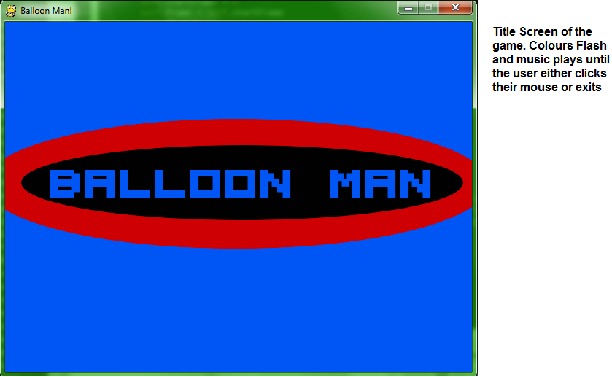

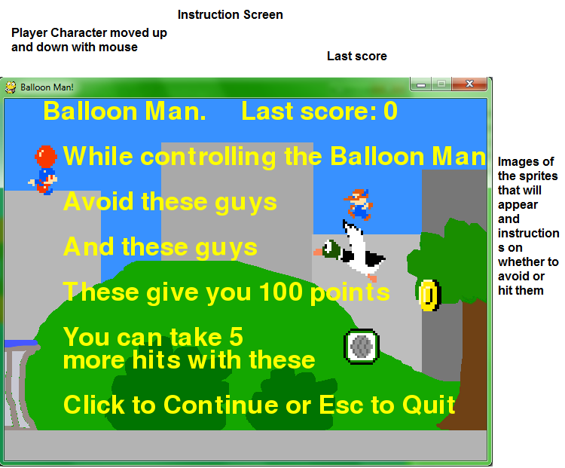

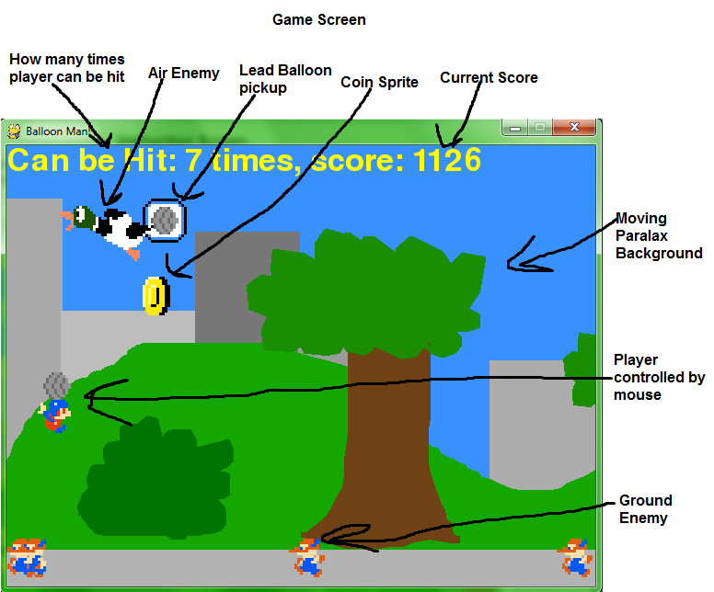

1. **Game World**

*It takes place on the edge of an ancient forest somewhere here on Earth.*

1. **Levels**

*There is only one level, the Park.*

1. **Game Progression**

*As long as the player’s health doesn’t reach 0 or all the barracks aren’t destroyed the player can progress.*

1. **Characters**

*The player’s avatar is part of a secret race of tiny people called Morrets. Their archenemies are the other tiny people race called the Pocklers. The player’s avatar has been assigned to scout as much of the Pockler controlled park, and collect as much of their gold, as he can.*

1. **Non-player Characters**

*There are no NPCs.*

1. **Enemies**

*There are two types of Enemies, the Pocklers who patrol on the ground and their evil duck allies who patrol the skies*

1. **Weapons**

*There are no weapons in this game.*

1. **Items**

*There are coins that, once the evil ducks appear, will appear at random heights on the screen and if the player hits them will give them 100 points. There is also an item that allows the player to be hit five extra times and makes the balloon look like it’s covered in lead.*

1. **Abilities**

*The player only has the ability to change their altitude.*

1. **Vehicles**

*The balloon attached to the player’s back is the only vehicle.*

1. **Script**

*There is no dialogue in this game.*

1. **Scoring**

*Scoring is based on how long the player can survive and how many coins they can collect.*

1. **Puzzles/Mini-games**

*No puzzles or Mini-games.*

1. **Bonuses**

*There are no bonuses.*

1. **Cheat Codes**

*No cheat codes.*

1. **Sound Index**

*TitleScreen.ogg*

*Lead.ogg*

*Instructions.ogg*

*GetCoin.ogg*

*GameMusic.ogg*

*GameMusic.ogg*

*GameFinish.ogg*

*BalloonPop.ogg*

1. **Story Index**

*The player’s avatar is part of a secret race of tiny people called Morrets. Their archenemies are the other tiny people race called the Pocklers. The player’s avatar has been assigned to scout as much of the Pockler controlled park, and collect as much of their gold, as he can.*

1. **Art / Multimedia Index**

*Sidewalk.gif*

*PlayerSpriteSheet.bmp*

*LeadBalloon.gif*

*Hills.gif*

*GEnemySpriteSheet.bmp*

*GEnemy3.gif*

*Foreground.gif*

*Coin.png*

*Character.png*

*BMTitle2.gif*

*BMTitle1.gif*

*BMTitle0.gif*

*Background.gif*

*AEnemySpriteSheet.bmp*

*AEnemy3.gif*

1. **Design Notes**

*(Include additional design notes here)*

1. **Future Features**

*(Include any future features that are planned to be implemented)*